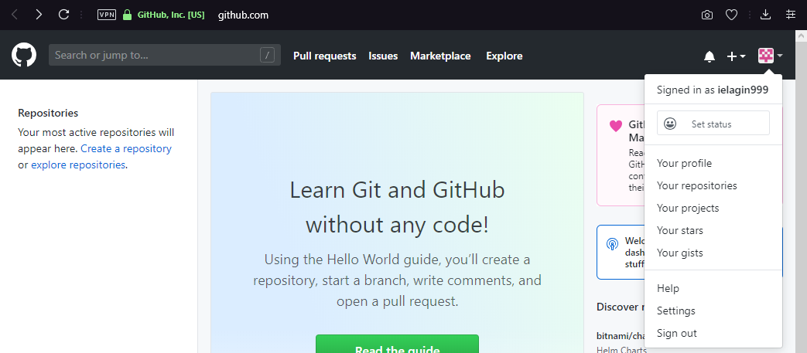

git confg --global user.name "Igor Elagin"

git config --global user.email "ielagin999@gmail.com"